**HTML Tables**

**Introduction**

An HTML table is defined with the <table> tag.

Each table row is defined with the <tr> tag. A table header is defined with the <th> tag. By default,

table headings are bold and centered. A table data/cell is defined with the <td> tag.

**Example:**

**<table style="width:100%">**

**<tr>**

**<th>Firstname</th>**

**<th>Lastname</th>**

**<th>Age</th>**

**</tr>**

**<tr>**

**<td>Jill</td>**

**<td>Smith</td>**

**<td>50</td>**

**</tr>**

**<tr>**

**<td>Eve</td>**

**<td>Jackson</td>**

**<td>94</td>**

**</tr>**

**</table>**

**Output:**

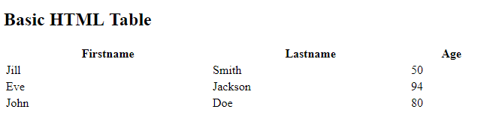

**Various HTML TAGS:**

|  |  |
| --- | --- |
| **Tag** | **Description** |
| <table> | Defines a table |
| <th> | Defines a header cell in a table |
| <tr> | Defines a row in a table |
| <td> | Defines a cell in a table |
| <caption> | Defines a table caption |
| <colgroup> | Specifies a group of one or more columns in a table for formatting |
| <col> | Specifies column properties for each column within a <colgroup> element |
| <thead> | Groups the header content in a table |
| <tbody> | Groups the body content in a table |
| <tfoot> | Groups the footer content in a table |

1. **table Tag**

The <table> tag defines an HTML table.

An HTML table consists of the <table> element and one or more <tr>, <th>, and <td> elements.

The <tr> element defines a table row, the <th> element defines a table header, and the <td> element defines a table cell.

A more complex HTML table may also include <caption>, <col>, <colgroup>, <thead>, <tfoot>, and <tbody> elements.

***NOTE****: Tables should not be used for page layout! Historically, some Web authors have misused tables in HTML as a way to control their page layout. However, there are a variety of alternatives to using HTML tables for layout, primarily using CSS.*

**Example:**

**<style>**

table, th, td {

border: 1px solid black;

}

**<style>**

**<table>**

**<tr>**

**<th>Month</th>**

**<th>Savings</th>**

**</tr>**

**<tr>**

**<td>January</td>**

**<td>$100</td>**

**</tr>**

**</table>**

**Output:**

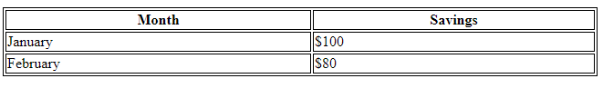

**2. thead Tag**

The <thead> tag is used to group header content in an HTML table.

The <thead> element is used in conjunction with the [<tbody>](https://www.w3schools.com/tags/tag_tbody.asp) and [<tfoot>](https://www.w3schools.com/tags/tag_tfoot.asp) elements to specify each part of a table (header, body, footer).

Browsers can use these elements to enable scrolling of the table body independently of the header and footer. Also, when printing a large table that spans multiple pages, these elements can enable the table header and footer to be printed at the top and bottom of each page.

The <thead> tag must be used in the following context: As a child of a <table> element, after any <caption>, and <colgroup> elements, and before any <tbody>, <tfoot>, and <tr> elements.

***Note:*** *The <thead> element must have one or more <tr> tags inside.*

***Tip:*** *The <thead>, <tbody>, and <tfoot> elements will not affect the layout of the table by default. However, you can use CSS to style these elements.*

**Example:**

**<table>**

**<thead>**

**<tr>**

**<th>Month</th>**

**<th>Savings</th>**

**</tr>**

**</thead>**

**<tbody>**

**<tr>**

**<td>January</td>**

**<td>$100</td>**

**</tr>**

**<tr>**

**<td>February</td>**

**<td>$80</td>**

**</tr>**

**</tbody>**

**<tfoot>**

**<tr>**

**<td>Sum</td>**

**<td>$180</td>**

**</tr>**

**</tfoot>**

**</table>**

**Output:**

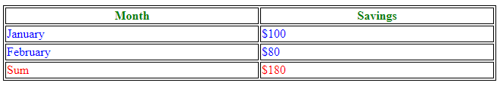

**3. tbody Tag**

The <tbody> tag is used to group the body content in an HTML table.

The <tbody> element is used in conjunction with the <thead> and <tfoot> elements to specify each part of a table (body, header, footer).

Browsers can use these elements to enable scrolling of the table body independently of the header and footer. Also, when printing a large table that spans multiple pages, these elements can enable the table header and footer to be printed at the top and bottom of each page.

The <tbody> tag must be used in the following context: As a child of a <table> element, after any <caption>, <colgroup>, and <thead> elements.

***Note 1:*** *The <tbody> element must have one or more <tr> tags inside.*

***Note 2:*** *The <thead>, <tbody>, and <tfoot> elements will not affect the layout of the table by default. However, you can use CSS to style these elements.*

**4. Caption**

The <caption> tag defines a table caption.

The <caption> tag must be inserted immediately after the <table> tag.

***Note:*** *You can specify only one caption per table.*

***Tip:*** *By default, a table caption will be center-aligned above a table. However, the CSS properties text-align and caption-side can be used to align and place the caption.*

**Example:**

**<table>**

**<caption>Monthly savings</caption>**

**<tr>**

**<th>Month</th>**

**<th>Savings</th>**

**</tr>**

**<tr>**

**<td>January</td>**

**<td>$100</td>**

**</tr>**

**</table>**

**Output:**

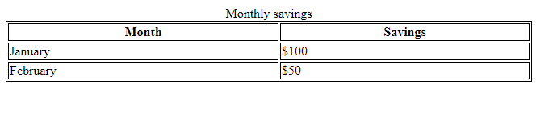

**Reference**

**https://www.w3schools.com/html/html_tables.asp**

**https://www.w3schools.com/tags/tag_caption.asp**

**https://www.w3schools.com/tags/tag_table.asp**

**https://www.w3schools.com/tags/tag_tbody.asp**

**https://www.w3schools.com/tags/tag_thead.asp**